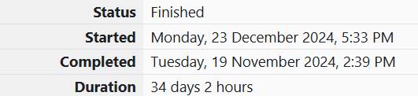

ROLL NO.: 241801281

NAME:SUJITHA NEELAKANDAN VIGNESHWARI

WEEK 05-01

1.OBJECTIVE:

Write a program that prints a simple chessboard.

CODE:

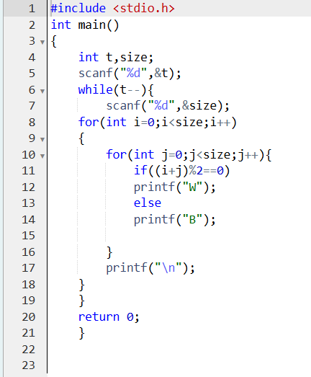

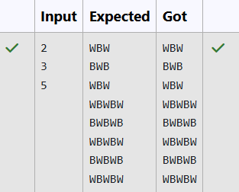OUTPUT:

2.OBJECTIVE:

Let’s print a chessboard!

CODE:

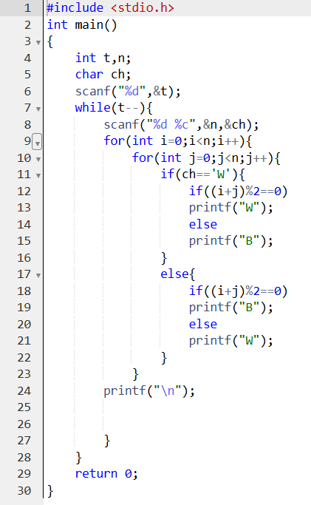

OUTPUT:

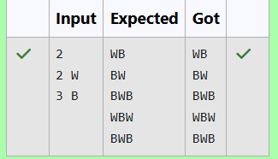

3.OBJECTIVE:

Decode the logic and print the Pattern that corresponds to given input.

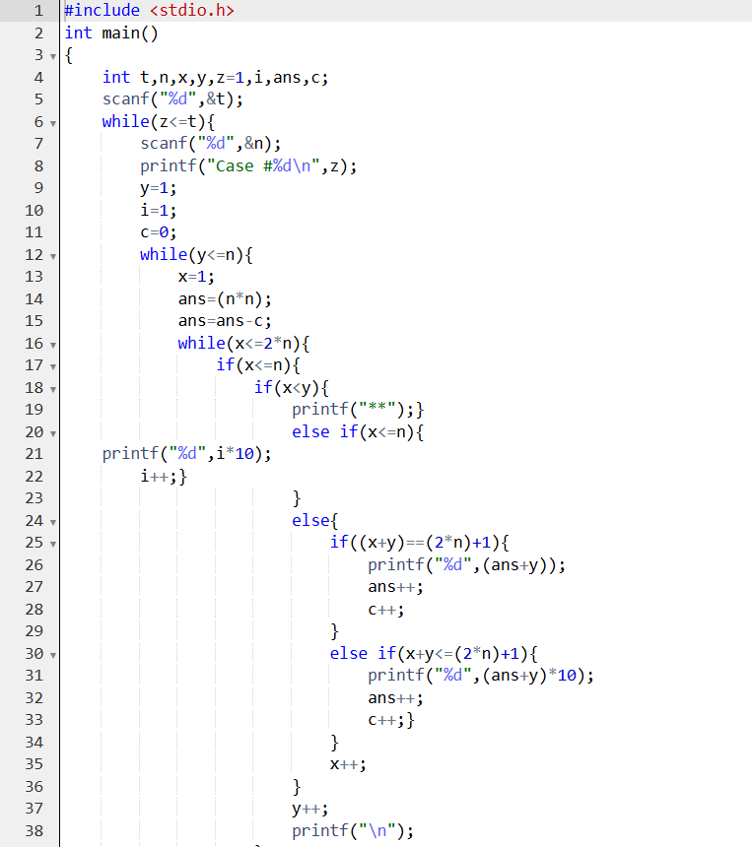CODE

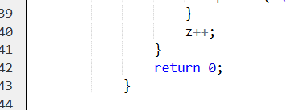

OUTPUT:

